### **Machine Learning based Vehicle Performance Analyzer**

**PROJECT MEMBERS:- MENTORS:-**

NISHANTH R YASHWANTHINI

SAI ABHISHEK M YASODHA

NAMAN MEHTA

DIYANESH ROHAN S

**ABSTRACT**

Predicting the performance level of cars is an important and interesting problem. The main goal is to predict the performance of the car to improve certain behaviours of the vehicle. This can significantly help to improve the system's fuel consumption and increase efficiency. The performance analysis of the car is based on the engine type, no of engine cylinders, fuel type, horsepower, etc. These are the factors on which the health of the car can be predicted. It is an ongoing process of obtaining, researching, analyzing, and recording health based on the above three factors. The performance objectives like mileage, dependability, flexibility and cost can be grouped together to play a vital role in the prediction engine and engine management system. This approach is a very important step towards understanding the vehicle's performance.

**1. LITERATURE SURVEY**

The range, durability and longevity of automotive traction batteries are ‘hot topics’ in automotive engineering. Hybrid and electric vehicles need power sources that will meet consumer expectations. The phenomenon of ‘range anxiety’ is well known, showing how important customers feel about range. The presence of ‘battery rental’ schemes for electric vehicles shows another concern: consumers want their purchases to last, and find the prospect of a key, expensive component ‘wearing out’ before its time worrying. We also know that the potential environmental benefits obtained using an electric vehicle will be reduced or even lost if the vehicle does not last at least as long as a conventional internal combustion engine vehicle. There are various implementations to increase the overall car performance, such as engine performance improvement, transmission and suspension system optimization, lubrication technology development, aerodynamic design, or driver course training, etc.

An existing solution is a Dynamometer, The laboratory experimental tool to measure the output performance of an engine or a vehicle is a dynamometer. It can be classified into various types depending on the criteria used for consideration. By installation, we separate dynamometers into two types; first, the engine dynamometer that directly connects an engine to a dynamometer; and second, the chassis dynamometer that can experiment by driving a car on the roller without taking the engine off. Both of them are used to measure and present the output power and torque of the engine at an operating speed . Moreover, we can classify dynamometers by a power transfer method and also split it into two types; the absorption dynamometer, and the transmission dynamometer. For the absorption type, dynamometers measure and absorb the engine output power to which they are coupled. The power absorbed is usually dissipated as heat by some means, such as prony brake, rope brake, mechanic or hydraulic friction, eddy-current dynamometer. For the transmission type, the power is transmitted to the load coupled to the engine after it is indicated on some types of scale. These are also called torque-meter. Inertia dynamometer is also included in the transmission type. The rolling mass (called drum) is designed to have enough inertia, directly connected to the engine, and loaded of the engine.

**2. ARCHITECTURE DIAGRAM**

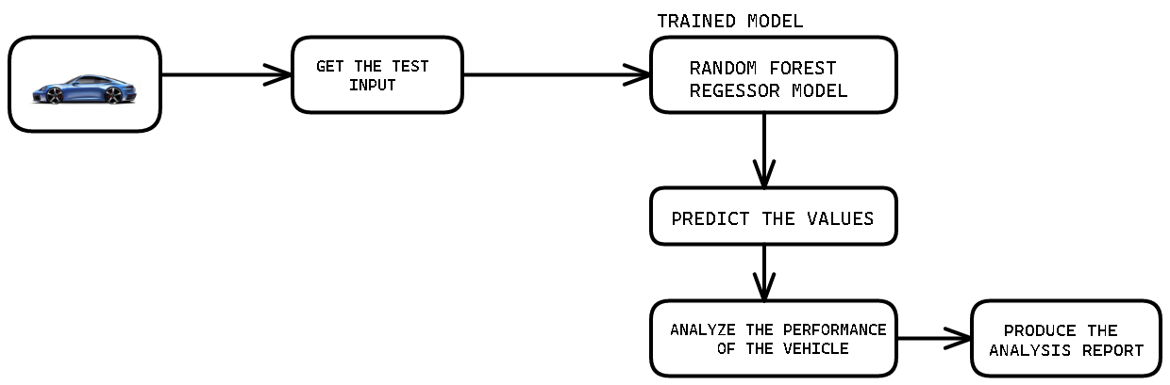

1. **PROJECT WORKFLOW**

START

USER INTERACTS WITH THE PERFORMANCE ANALYZER

RECORDED DATA IS SENT TO THE MODEL

STOP

PREDICTED DATA IS USED TO TUNE THE CAR ACCORDING TO THE CUSTOMER.

DESIRED METRIC IS ANALYZED.

**To accomplish this, we have to complete all the activities and tasks listed below:**

**WORKING :**

1. Data Collection.

a. Collect the dataset or Create the dataset

2. Data Preprocessing.

a. Import the Libraries.

b. Importing the dataset.

c. Checking for Null Values.

d. Data Visualization.

e. Taking care of Missing Data.

F. Label encoding.

g. One Hot Encoding.

h. Feature Scaling.

i. Splitting Data into Train and Test.

3. Model Building

a. Training and testing the model

b. Evaluation of Model

4. Application Building

a. Create an HTML file

b. Build a Python Code